Keith Aizawa  Legal Name  Kiichiro Aizawa  Contact  6577575063  keith.azw@gmail.com  BIo  Height: 5’7  Eyes: Black  Weight: 130  Hair: Black  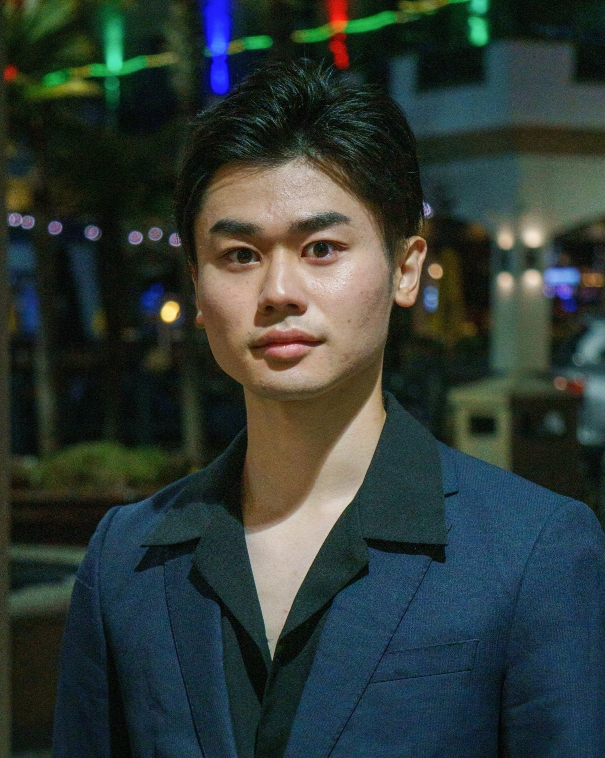 |  | Films  They Took My Father Too Lead Photosynth Entertainment  Impulse Lead Daniel Fim Production  Fireworks Supporting Elijvh Entertainment  Composure Lead Nico Production  Filtered! Lead USC SAG Project  Retry! Lead USC SAG Project  Love Again Supporting USC SAG Project  Tribunal Justice Background Amazon Prime  Broke Kid Changes The World Background Changing Lives Production  Final Fight Lead Dillon Leavitt Films  NOBODY Lead NIC Production  Your tea. Lead NIC Production  Commercial  T-Mobile Lead T-Mobile x Sonic the Hedgehog 3  Amazon Photos Presenter Amazon Photos  Amazon Alexa Custom Assistant Lead Corporate Video  Event  Ninja Warrior Lead OC JAPAN FAIR  MC (April 2024) OC JAPAN FAIR  Kimono Model (April, October 2024, April 2025) OC JAPAN FAIR  VOICE ACTING  Dude Perfect Supporting Dude Perfect Production  SpinX Games Limited Lead SpinX Games  Theatre  RENT Supporting Orange Coast College  HOME FOR THE CHALIDAYS Lead Orange Coast College REP  Hazbin Hotel Lead Orange Coast College REP  Beef Lead Orange Coast College REP  Skills  - Stage Combat with Sword ・ Acrobatics  - Aikido (Martial Arts): Black Belt ・ Tea Ceremony  - Mixed Martial Arts ・ Parkour  - Stunts ・ Piano  - Dance (Hip hop, Ballroom) ・ Basketball  - Japanese  ACCOMPLISHMENTS  - Scholarship Recipient  - 3.94 GPA  - PHI THETA KAPPA HONOR SOCIETY MEMBER

