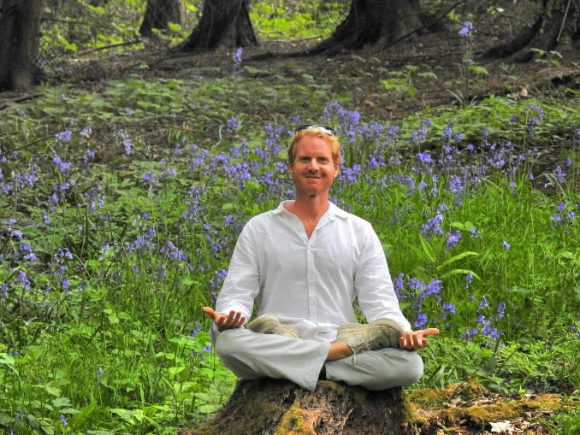

**ANDY BANKS**

39 years old, male.

Qualifications:

200 and 300 (500) hours’ Vikasa Training Koh Samui: March – June 2019, Hatha style

65 hours’ Yin yoga training Feb 26th – March 4th 2023

200 hours Hatha and Ashtanga at Aadi Yoga, Rishikesh

Teaching –

Teaching yoga at Lust Surf and Yoga Villa, Sri Lanka for three months. (2020)

20 or so online classes taught

Few classes taught with staff at last company in England

3 weeks of yoga and some massage at Kitesurfing retreat in Morocco April 2025

Example – YouTube – Yoga with Andy – some classes here

<https://m.youtube.com/@yogawithandy7590>

In addition:

Thai massage qualified- 150 hours at TMC in Chiang Mai completed Dec 19 – Jan 2020

Anatomy, Physiology and Pathology NVW Level 3 passed in March 2024

One month Avurvedic Massage and Nutrition course completed.  March/April 2024 (140 hours)

6 day Sound Healing with singing bowls to go alongside the Yin – April 2024.

4 day Marma point massage course May 2024.

12 day sound healing with singing bowls June 2024.

10 day intro to Buddhism silent meditation retreat in Tushita, Dharamsala, July 2024

Hoping to find a team to be a part of, learn and developing whilst practicing existing skills in a professional and enjoyable fashion. Ideally earning money but at least breaking even.

Long term, would like to pick up enough experience to run a retreat and maybe even own one day if can find the means… yoga, massage, sound healing, healthy food, sustainable living, salsa/bachata and surfing.