Britney Lamb  Hair: Black/Dark Brown Weight: 140 lbs. Height: 5’4  Eyes: Black/Dark Brown Vocal: Alto |  | 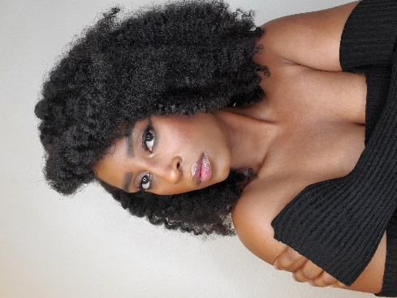

Theater
The Gospel Wiz Munchkin #2 Star Theatre, Wesley Moore
Love and Happiness Tiffany McCoy Beyond Limits Productions, Crystal Grant
A Burning Desire Victoria Jones Star Theatre, Temia Hubbard

Skills
- Singing (alto)
- Dance (praise and hip-hop)
- Choreographer (praise dance)
- Track and Field (collegiate level: mid-distance, hurdler, sprinter, long jump, and triple jump)
- Volleyball (high school level)
- Jump rope
- Model
- Intermediate clarinet player
- Computer (typing 60 wpm, 10-key touch)
- Good with children
- Calm under pressure

Training

Acting: Tasha Smith Acting Workshop (TSAW), Erik Rudo

Voice: Morning Star Missionary Baptist Church Choir; Lawrence Haynes

Dance: Morning Star Missionary Baptist Church Praise Dance; Jackie Joyner Kersee Boys & Girls Club

 |  | Contact
460 Forest Park Blvd., Apt. 312
Oxnard, CA 93036
 |  | (618) 407 – 6305
 |  | bcallen1989@gmail.com
 |  | Your Website

