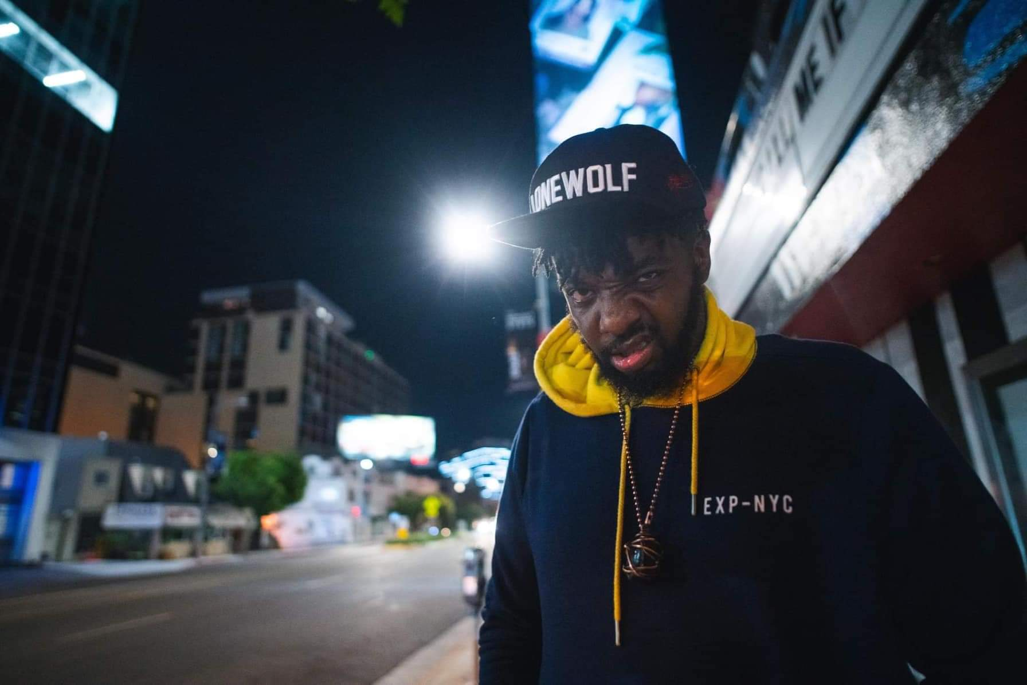

Name: KILLAMIND (William Mossett )
From: Philadelphia, Pa (Currently living in Los Angeles, Ca)
Title(s): Emcee / Host / Hip hop Artist / Promoter / Entertainer
Contact Information:
1-215-960-6262- (Personal)
1-267-752-3992 (Business)
KILLAMIND@GMAIL.COM
KILLAMIND.COM
Linktree/com/killamind

KILLAMIND is a Philadelphia raised Hip Hop Artist that is also known as the most interactive, animated and entertaining Emcee’s.
Killamind has hosted at every major club venue in the Philadelphia area with most of the top well known Dj’s in the Philadelphia area including guest Dj’s and have traveled with some of these Dj’s, Killamind had the opportunity to guest host for Dj Jazzy Jeff at the closing of Fluid Nightclub in Philly with alongside (Emcee: Yahmeen Allworld and Amir Questlove from The Roots).

With experience in music and radio, Killamind’s focus is to keep the energy up and excite the crowed; he has an unorthodox way to how he interacts where you expect the unexpected in an entertaining way. He lives his life to the fullest and started a movement called #SMASHBOXLYFE for people who wants’ to achieve their goals and enjoys life.
Killamind is not your average host/emcee that a lot of people are use to but is the type of host/emcee that you need.

Dj’s Killamind hosted for:
Dj Aktive , Dj Statik aka Mr. Sonny James (Illvibe collective Crew) , Mike Nyce, Dj Phsh ( Illvibe collective crew ) , Dj Jay Ski , Mr. Hollywood , Dj Omega , Dj A-Run, Dj Beat Street, Patrice McBride ,Dj Jovi , Dj Excell , Dj Brenden Bringem , Dj Royal ( just to name a few )
Clubs Killamind Hosted at:
Philadelphia : Walnut Room, Vango Skybar , Rain Lounge, Whispers Nightclub , Fluid Nightclub , Kung Fu Necktie , Blue Martini , Trilogy (and many more…)
Las Vegas: Insert Coins
Experience:
2004 - Guest Radio Personality every Wednesday’s for Philadelphia WUSL Power 99’s show “Sex & Slow Jams with Sol the Controller & Lady-t “
2005- (Present) – Emcee/Host
Killamind Emcee/Hosted at all major club/lounge event and venues in the Philadelphia area for all the top Dj’s known in radio and night clubs.
2009 – Killamind released his debut mix tape “The Target” with a follow up mix tape “Expect the Unexpected”

2009-2011 – Killamind reunited with the staff of sex and slow jams and started a new online radio show with FMDMS.com titled “Real Radio” Where we spoke on current events, music, politics and Killamind introduced the up and coming music artist.

2013-2018 – Killamind released 2 mixtapes and a album with a few music video’s
2015 - !SRAM MORF MI mixtape with DJ Benz is released
2017- Tha WUTUPSKI #SMASHBOXLYFE mixtape is released
2018 – AUDIOVISION the album is released
2021- Hosted #SMASHBOXLYFE summer social event in Philadelphia, PA.
2022- Released new singles and music videos for upcoming projects

Killamind has also been making special appearance guest host for featured DJ’s upon request in the Los Angeles, Philadelphia, Arizona, Las Vegas and Atlanta area’s from 2013- present

He brings a welcoming high positive and fun energy to a party audience that keeps them returning for more and is highly aware of all sales targets to keep the crowed engaged and entertained.
