*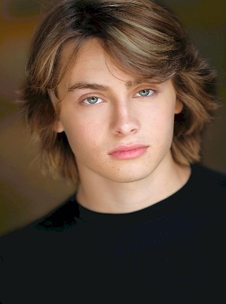****Ryker Baloun*** *SAG-AFTRA*

**310.288.8051  Jennifer Millar/Paradigm Talent** [**Jmillar@paradigmagency.com**](mailto:Jmillar@paradigmagency.com) **,** [**lhatcher@paradigmagency.com**](mailto:lhatcher@paradigmagency.com)

**310-927-9308  Kim Matuka /Schuller Talent  schullertalent@gmail.com**

**FILM**

*The Magic* Co-Star Lani Prod/Greggori Martin

*Oakdale* LeadJosh Garvin

*Topic Of Grief*  LeadPretty Is Productions

*The Confab*  LeadPaul Hartel

*The Future Feature* Co-StarMiranda July

*Mental (Short)* Co-Star Jennifer Cron

**EPISODIC/TV**

*The Conners*  Tyler Tom Werner

*The Rookie* Stoned TeenagerNathan Fillion

*Chicken Girls* Co-Star Dave Brat TV

*Barry (HBO)* Co-Star hammer (cut scene) Bill Hader/Alec Berg

*Breaking In* Co-star (younger version) Adam Goldberg

**THEATRE**

*The Diviners* Lead: Buddy Layman NPAC /CB Rand

**EDUCATION & TRAINING**

Acting intensives: John Kirby, Chris Game, John Posey, Lisa Picotte, David Gray and more

Stunt Master Class: Travis Wong, Garret Warren, Phil Tan, Arnold Chon, Fabien Garcia and more

**SPECIAL SKILLS**

Horseback, Hockey, skating (snow, roller, inline etc.) stunt fighting, guns, accents (southern, English, cockney)

Commercial Resume available on request.