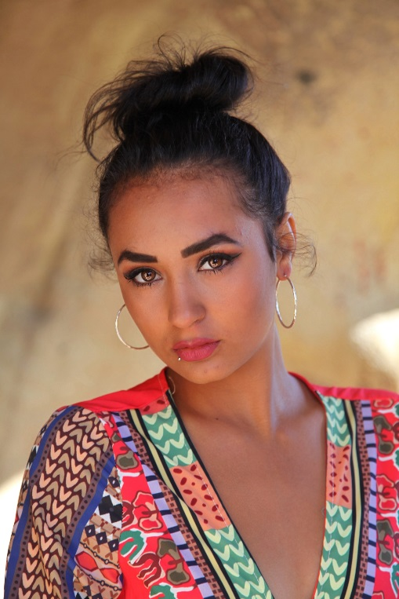Alyssa Sage Boulton

10072 Stilbite Ave

Fountain Valley, CA 92708

Email [alyssasboulton@gmail.com](mailto:alyssasboulton@gmail.com)

Facebook [www.facebook.com/Alyssa-Boulton-Model-1710365125844406](http://www.facebook.com/Alyssa-Boulton-Model-1710365125844406)

IG: Instagram.com/alyssa.sagex

**Bust 29”**

**Waist 25”**

**Hips 36”**

**Upper back 19”**

**Arm length 21.5”**

**Leg length 36”**

**Height 5.4**

**Weight 120**

**Foot Size 7 1/2**

**Eyes / hair Brown**

Objective

To Make the Modeling Industry a successful Career for my future

**AUTOSHOWS / AUTOTRADE**

2019 July – VIDCON Anaheim Convention / The Bachelor Party Red Carpet Promotions

2018 LA DUB show

2017 Anaheim DUB show

2017 742RWLA / Model

2016 Import Face / off / trophy girl

2016 Hot Import Nights HIN Girl

2015, 2016 Dub Show – LA Convention

2015 Extreme Auto fest – Anaheim CA

2014 LA DUB show

**PROMOTIONS**

2019 July Gatorade / ATN

2019 July Coca Cola promotion / ATN

2019 July Zoi Cosmetics

2017 What’s your motivation Hip Hop Show case

**GROUP SHOOT**

2019 May Heavy Metal shoot / Lumino Studios

2019 Apr. Massacre Shoot / Lumino Studios

**2018** Oct. Zombie shoot / Lumino Studios

2018 May Boulton Girls Published Group shoot

2018 Apr. Boulton Girls exotic Car shoot

2017 Gardena Camera Club / Model

2017 - 2018 Lumino Studios /Multiple events

2017 / Sept. Waterworld Group Shoot

2017 /Feb. & Mar. New Camera Face Group Shoot

2017/Jan. New Camera Face Group Shoot / First Place Teen

2016 Inland Empire Camera Club Group Shoot

2016 New Camera Face Group shoot

2016 Cable Air Show Group Shoot

2015 Mike Bean photo Workshop

2011 Joe Duerr Photo Workshop Centennial Park

**CLOTHING /DESIGNER**

2019 July Calypso Harem Fashions

2019 June Christine Tenille

2019 – Links by Gwen / CIE Fashion show

2018 - 2019 Trisha

2018 Tommy Le (Designer for Crazy Rich Asian) / CIM Model

2018 One World Peace

2018 Josway Networks / CIM Models

2018 Taj Couture / Exclusive CIM Models

2018 Hey Baby Bikini

2018 Nicole Shante

2018 Hookini Bikinis

2016 ADPT Clothing

2015 Whanda’s Boutique

2017 Jewelry and Clothing Designer Sweets Jewelry- Carol Lynn Sweets

2017 Cherry Designs

**EXTRA / TV**

2019 July Masked singer / Audience Casting Connections

2016 Rosewood / Extra girl

2016 Boss Girl / Extra Dance scene

2015 Scandal / Mini Gulf Course background

**COMMERCIAL**

2016 CJ Korea / Group concert / Elite Kids Talent

**RUNWAY**

2019 BET Experience Fashion show CIM Model / Raven Wilson

2019 Kiss the monkey Fashion Show CIM Model / Raven Wilson

2019 CIE Fashion show – CIM Model

2019 Heart of Hollywood Fashion show – CIM Model

2018 Kiss the Monkey Unleashed – CIM Models

2018 LAFW – For the Love of Fashion – CIM Models

2018 Raw Artist Runway fashion show / Exclusive CIM Models

2018 Nicole Shante fashion show

2015 Designer Emilio Fashion Show

2015 Sheer Elegant Fashion Show/Ontario Airport Hotel/Designer Whanda

**PRINT / MAGAZINE**

2018 CIE Fashion Magazine / CIM Exclusive Models

2018 INDIKIDS Fall issue Addyson Cover

2017 CIE Cover 1st Youth addition

2017 CIE Fashion Magazine

2017 Wheels and Heels Magazine

2016 Wheels and Heels Magazine

**GALLERY**

2018 Artlife Gallery – Los Angeles by Joanne Mattillo

**TRAINING / MANAGER /CASTING**

2018 La Quinta HS Drama / Thespian Award

2018 CIM Management – Raven Wilson

2018 Prestigious Model Talent Agency

2016 Elite Kids Talent

Laquinta High School 2014 – 2018 Drama

CESD Agency

Central Casting

La Casting

Studio Kids / Extra TV work

Tupua Production – Dancer

Mr. Clean Promotions

Patrice – LA Casting Scout

**VIDEOS / MUSIC**

2019 July Demo Reel Alyssa Boulton <https://vimeo.com/348050719>

2019 July Demo reel Explorer Studios <https://vimeo.com/124246654>

2018 Chris Cash

2018AE – Falling Apart <https://youtu.be/lwP61oA6jnY>

Erica Dorsey 2015 <http://youtu.be/2MsMkfR6icU>

<https://youtu.be/OE3iPm5P-Rw>

**WEBSITE**

2018 July Silverline Frenchies / Dog shoot

2015 Guitar Spy Website Featured Model

**MAKE UP**

2018 Luciano Paesani / Zombie / Lumino Studios

2018 Patrice

2018 Blake

2017 Dorothy / Lumino Studios - 714/369-0807 @dorothydoesmakeup

2015 Noeun Peang