Chelsea Lydell
chelsea.lydell@gmail.com

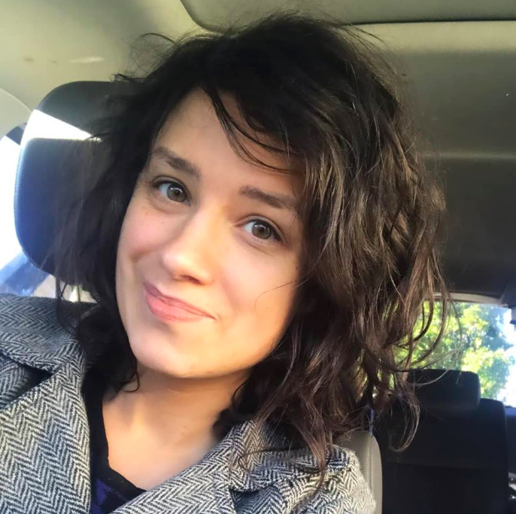
SKILLS
* Fluent in American Sign Language & written English
* Efficient and self-motivated
* Active influencer in her industry niche
* Team player & collaborator
* Prolific content creator
* Quick thinker and problem-solver
* Social media & digital media proficient

RECENT ROLES
Name of Shoot | Type | Role
Apple Inc. | Still Photography | Model
The Mother’s Eye | Short Film | Actress
Agents of Change | Musical | Actress

EXPERIENCE

Novus Select - Lake Tahoe, CA - Model
JUNE 2019 - PRESENT
- Apple at Work - Still Photography Shoot

HeartTouch Productions Granite Bay, CA - Executive Producer

February 2018 - PRESENT
- Logistical coordinator for a debut film
- Script editor for upcoming 2020 feature-length film

Suit to Suit - Content Creator
February 2018 - September 2018
- Branding and content

EDUCATION

EMERGE ACADEMY - Sales & Leadership Certification
May 2018 - November 2018

AWARDS
One of only three (3) Deaf holistic medicine small business owners in U.S.
to achieve national leadership status and $200,000 in annual sales

