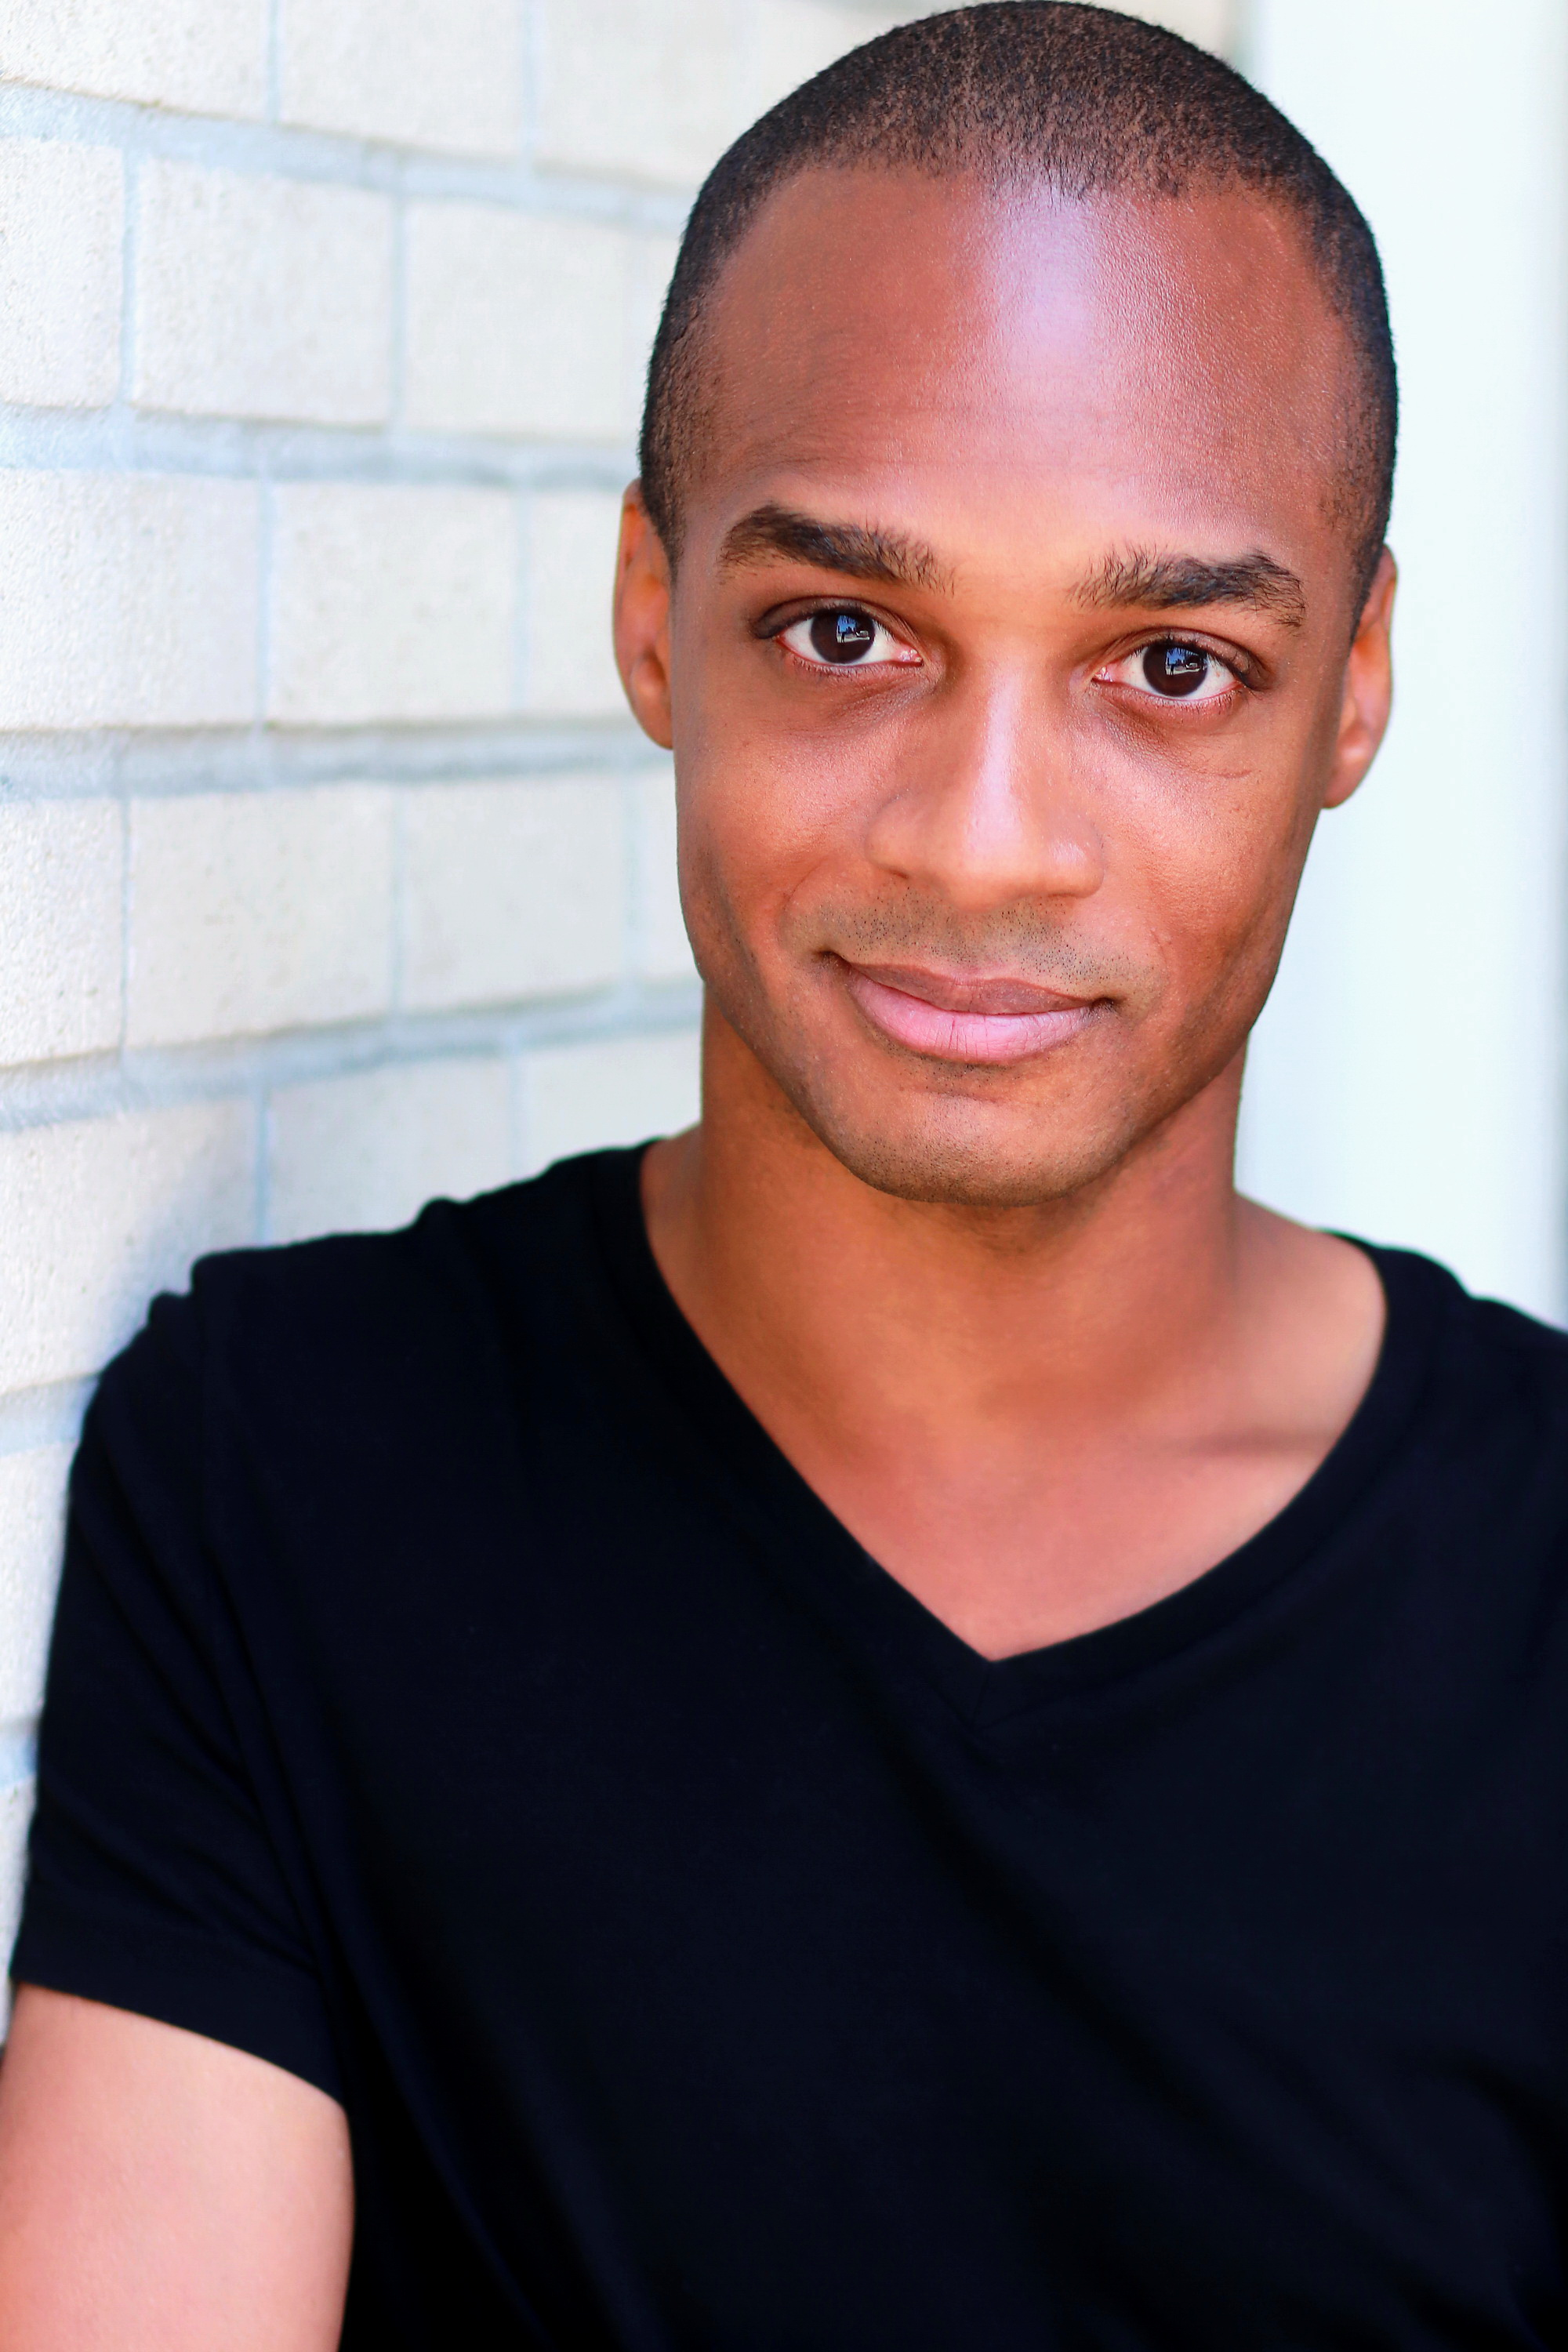
Andrew Searles
ACTRA Apprentice
www.AndrewSearles.com
Cell: 818-357-3563

Height : 5ft 11
Weight : 165 lbs.
Hair : Black
Eyes : Brown

FILM
Shark Boy Principle Role Kidnapper Films
Geeks Underground Voice over Jonathan Starr
Delivering the Goods Principle Role Sukhi Benning
Jesus Saves Voice over Elias Varoutsos

Cereal Killer Principle Role Fabrice Barthelemy
Remove Principle Role Didier Theo
MDMA Supporting Role Andre Dawson

TELEVISION
Fatal Vows Guest Star Investigation Discovery
No Kidding (Comedy Special) Himself iChannel
Inheriting Trouble 2: Ep 307 Actor Discovery Channel
Kalam Al Nas (“Gossip”) Guest Star STV-1 Saudi Arabia

COMMERCIALS
McDonald’s “Office” commercial Principle Role McDonalds Canada
Sunshine on Me (Commercial) Actor Florida Department of Citrus
Moores Clothing 2013 commercials Principle Role Moores Clothing
Great Wolf Lodge (Commercial) Principle Role USA Network
US Nexus Cards (In Airport Commercial) Principle Role Government of Canada
Pub Pere Noel La Dinde: Mona Turkey Principle Role CanalSat

TRAINING
Audition Workshop Elite Casting, Montreal, Qc
Audition Workshop Andrea Kenyon Casting, Montreal, Qc
Acting Foundation I & II Montreal School of Performing Arts
Intermediate Acting Class (Ongoing) Margie Haber Studio, Los Angeles

SPECIAL KILLS
- Stand-up Comedian (Ice House, Flappers, ComedyWorks, Comedy Nest, Absolute Comedy)
- Comedy Festivals: Calgary Folk Festival. Natal Day Comedy Gala.
- Celebrity Impressions (Arnold Schwarzenegger, Eddie Murphy, Elmo, Kermit the Frog, Elmo, Mr.Bean)
- Improv (Comedic: Frequently interacts with the audience during a Stand-up performance)
- Legal Canadian Passport.

